**Object Oriented Programming**

**Lab Report**

**Lab02**



|  |  |
| --- | --- |
| Group Members Name & Reg #: | **Muhammad Haris Irfan**  **(FA18-BCE-090)** |
|  |  |
| Class | Object Oriented Programming CSC241 (**BCE-4B**) |
| Instructor’s Name | Maam Amber Madeeha Zeb |

**In Lab Tasks**

**5.1 Task 1:**

**Write a class that displays a simple message “I am object no. __”, on the screen whenever an object of that class is created.**

**Solution:**The code is given below,

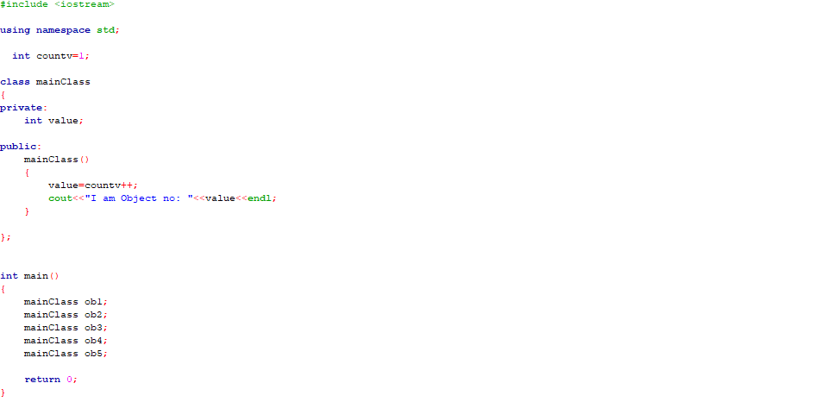

Console Output solution is shown below.

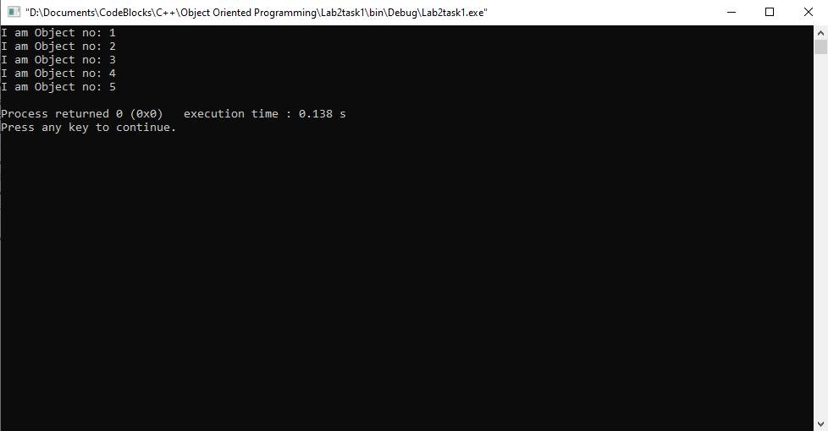

____________________________

**5.2 Task:2**

Create a class that imitates part of the functionality of the basic data type int, call the class Int. The only data in this class is an integer variable. Include member functions to initialize an Int to zero, to initialize it to an integer value and to display it. Write a program that exercises this class by creating an Int variable and calling its member functions.

Solution:

I am attaching my code below,

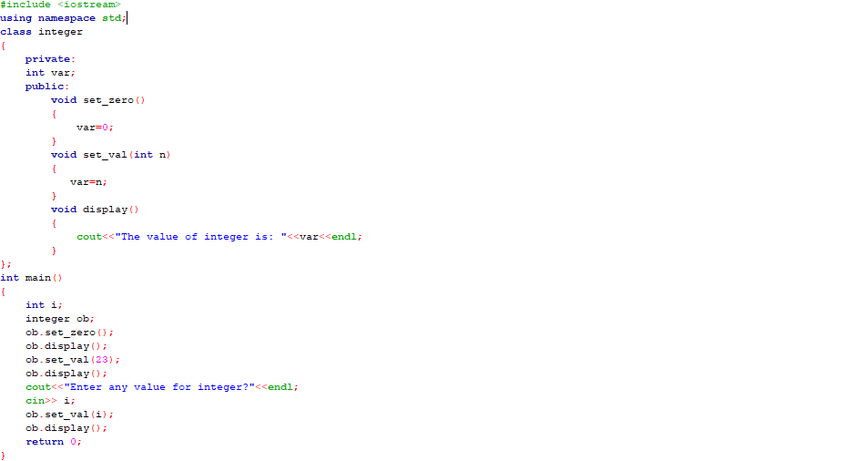

The result for this program is shown below,

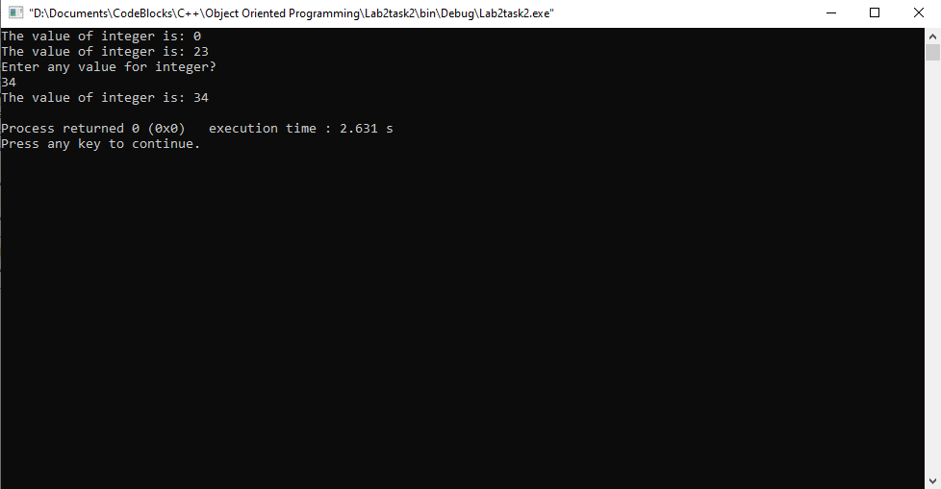

_____________________________

POST LAB

6.1 Question 1:

Write a program to calculate the number of objects created and destroyed for the counter class.

Solution:

I am attaching my code below,

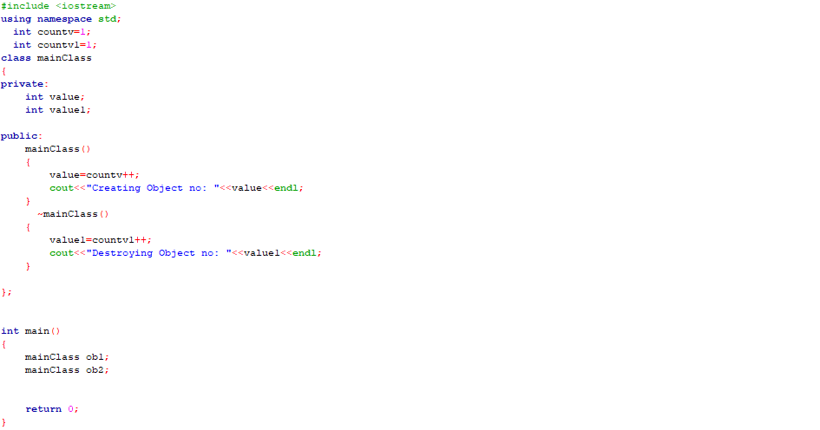

The result for this program is shown below,

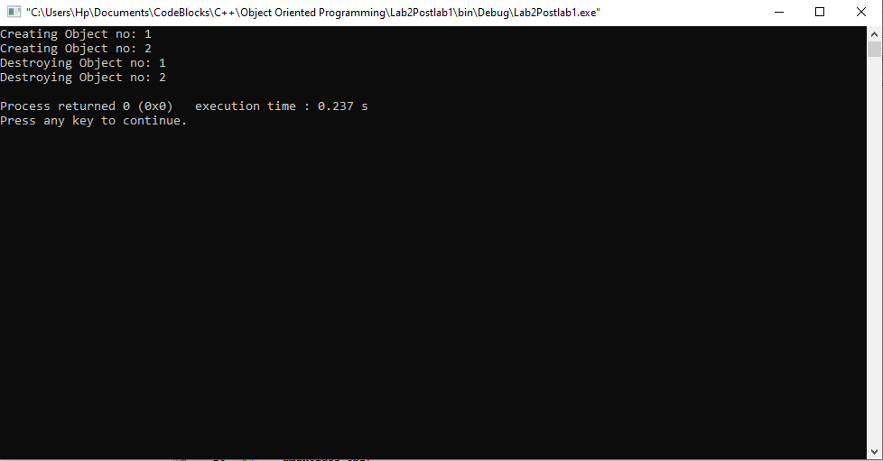

_______________

6.2 Question 2:

**Create a class named time, the data members are hours, minutes and seconds. Write a function to read the data members supplied by the user, write a function to display the data members in standard (24) hour and also in (12) hour format.**

Solution:

I am attaching my code below,

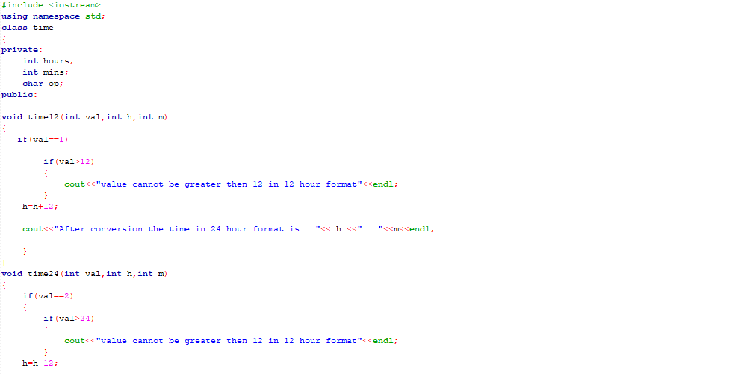

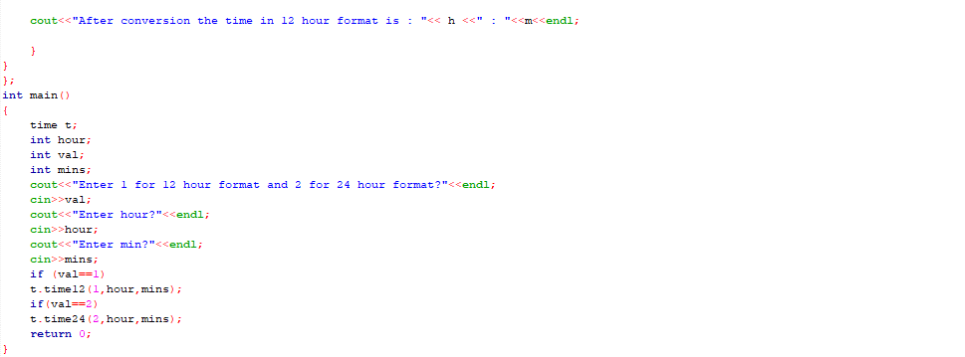

The result for this program is shown below,

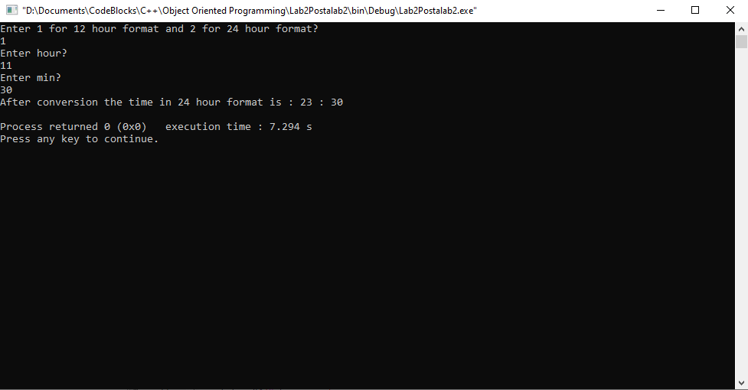

The above sorting is done by passing reference, because you cannot pass an array by value.

_______________

6.3 Question 3:

**Write a class marks with three data members to store three marks. Write three member functions, set_marks() to input marks, sum() to calculate and return the sum and avg() to calculate and return average marks.**

Solution:

I am attaching my code below,

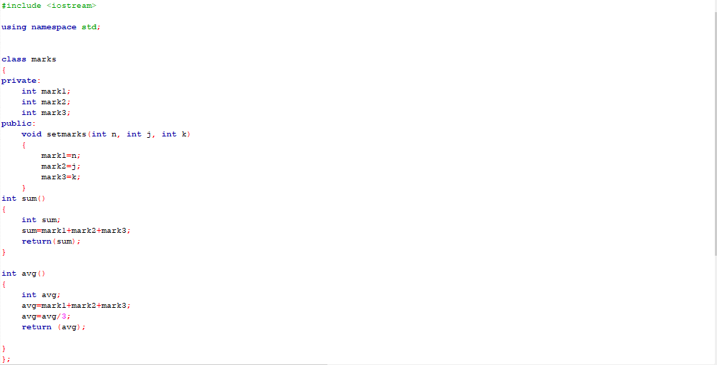

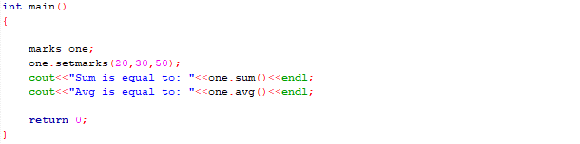

The result for this program is shown below,

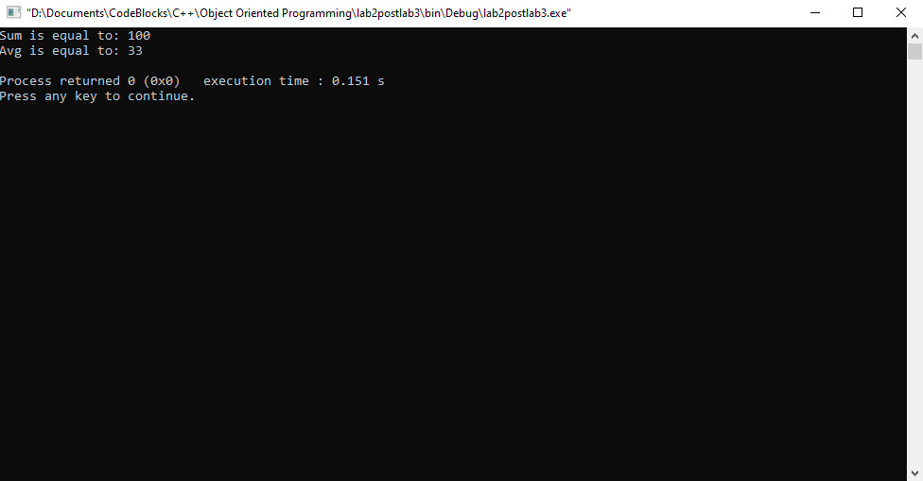

______THE END________

_______________